Category A Java Basics

A1-WAP program to find Area and Perimeter of Circle.  Accept radius as command line argument.

**Code:**

public class CircleArea

{

public static void main (String[] args)

{

double r, a,p ;

r = Double.parseDouble(args[0]);

a = Math.PI*r*r;

p = 2*Math.PI*r;

System.out.println("Area of circle with radius r = "+r+" is "+a);

System.out.println("Perimeter of circle with radius r = "+r+" is "+p);

}

}

**Output:**

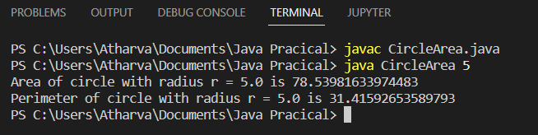

A2-Sales tax in some City is 8.25%. Write a program that accepts a price on the command line and prints out the appropriate tax and total purchase price.

**Code:**

public class TaxCalculation {

public static void main(String[] args)

{

double Price, Tax, Total;

Price = Double.parseDouble(args[0]);

Tax = Price*(8.25/100);

Total = Price+Tax;

System.out.println("Tax= "+Tax+"\n Total price= "+Total);

}

}

**Output:**

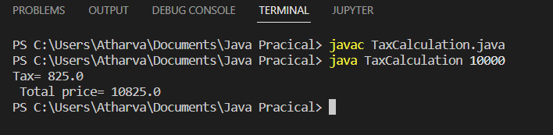

**A3-** There are exactly 2.54 centimeters to an inch. Write a program that takes a number of inches from the command line and converts it to centimeters.

**Code:**

public class InchToCM {

public static void main(String[] args)

{

float inch,cm;

inch = Float.parseFloat(args[0]);

cm = inch*2.54F;

System.out.println(inch+" Inch= "+cm+" centimeters");

}

}

**Output:**

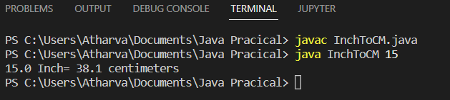

**A4-**  Write a program to find solution of quadratic equation.  Accept a, b and c from user.

**Code:**

import java.util.Scanner;

public class QuadraticEq {

public static void main(String[] args)

{

double a, b, c, root1, root2;

System.out.println("For given equation ax^2+bx+c");

System.out.print("Enter a: ");

Scanner sc=new Scanner(System.in);

a = sc.nextDouble();

System.out.print("\nEnter b: ");

b = sc.nextDouble();

System.out.print("\nEnter c: ");

c = sc.nextDouble();

double d=(b*b)-(4*a*c);

System.out.println("Discriminant= "+d);

sc.close();

if(d>0)

{

System.out.println("Roots are real and they are unequal");

root1 = (-b+Math.sqrt(d))/(2*a);

root2 = (-b-Math.sqrt(d))/(2*a);

System.out.println("Root1= "+root1);

System.out.println("Root2= "+root2);

}

else if(d==0)

{

System.out.println("Roots are real and they are equal");

root1 = (-b+Math.sqrt(d))/(2*a);

System.out.println("Root1= "+root1);

}

else

{

System.out.println("Roots are IMAGINARY");

}

}

}

**Output:**

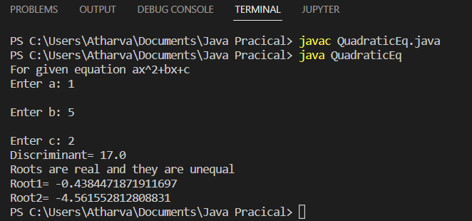

**A5-** Write a program to Calculate the Sum of Digits of Given any Number.

**Code:**

import java.util.Scanner;

public class SumOfDigits {

public static void main(String[] args)

{

Scanner sc = new Scanner(System.in);

int n, no, r, sum=0;

System.out.println("Enter a number: ");

no = sc.nextInt();

sc.close();

n = no;

while(n>0)

{

r = n%10;

sum = sum+r;

n = n/10;

}

System.out.println("Sum of digits of "+no+" is "+sum);

}

}

**Output**:

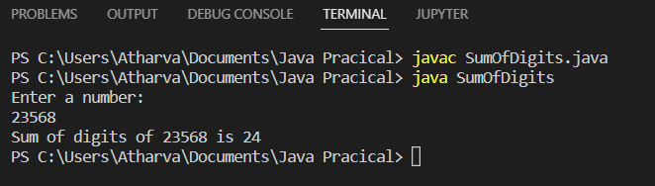

**A6-** Write a program Check upper case or lower case of character.

**Code:**

import java.util.Scanner;

public class CheckCharCase {

public static void main(String[] args)

{

Scanner sc = new Scanner (System.in);

System.out.println("Enter Character: ");

String c = sc.next();

char ch = c.charAt(0);

sc.close();

if(ch>=65 && ch<=90)

{

System.out.println(ch+" is Upper Case Character.");

}

else if(ch>=97 && ch<=122)

{

System.out.println(ch+" is Lower Case Character.");

}

else

{

System.out.println("Enter Character");

}

}

}

**Output:**

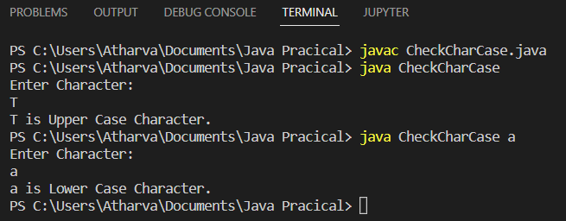

**A7-** Write a program to find whether entered character is a vowel consonant number or a special character.

**Code:**

import java.util.Scanner;

public class CheckVowelSpecial {

public static void main(String[] args)

{

Scanner sc = new Scanner(System.in);

System.out.println("Enter Character: ");

String c = sc.next().toLowerCase();

char ch = c.charAt(0);

sc.close();

if(ch>='a' && ch<='z')

{

if(ch=='a'||ch=='e'||ch=='i'||ch=='o'||ch=='u')

{

System.out.println(ch+" is a vowel");

}

else

{

System.out.println(ch+" is a consonant");

}

}

else if(ch>='0' && ch<='9')

{

System.out.println(ch+" is a number");

}

else

{

System.out.println(ch+" is a special character");

}

}

}

**Output:**

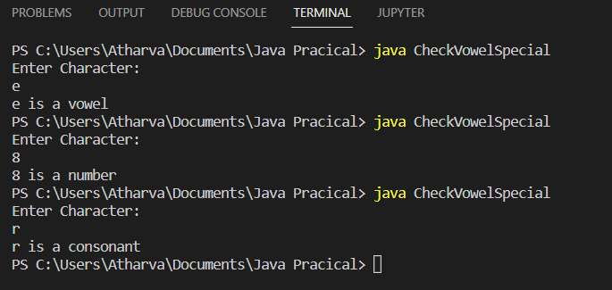

**A8-** Write a Java program to find the maximum and minimum value of an array.

**Code:**

import java.util.Scanner;

public class ArrayStat {

public static void main(String[] args)

{

int n, temp;

Scanner sc = new Scanner(System.in);

System.out.print("Enter no. of elements in array: ");

n = sc.nextInt();

int[] a = new int[n];

System.out.println("Enter "+n+" elements of array a: ");

for(int i=0 ; i<n ; i++)

{

a[i] = sc.nextInt();

}

System.out.println("Array elements are: ");

sc.close();

for(int i=0 ; i<n ; i++)

{

System.out.print(a[i] +"\t");

}

for(int i=0 ; i<n ; i++)

{

for(int j=i+1 ; j<n ; j++)

{

if(a[i]>a[j])

{

temp=a[i];

a[i]=a[j];

a[j]=temp;

}

}

}

System.out.println("\n Min value is: "+a[0]+"\n Max value is: "+a[n-1]);

}

}

**Output:**

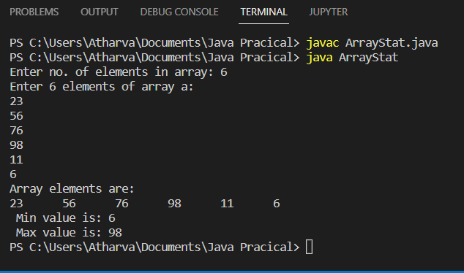

**A9-** Write a Java program to find addition of two matrices. Accept matrix from user.

**Code:**

import java.util.Scanner;

public class AddMatrices {

public static void main(String[] args)

{

int row, col;

Scanner sc = new Scanner(System.in);

System.out.print("Input number of rows: ");

row = sc.nextInt();

System.out.print("Input number of cols: ");

col = sc.nextInt();

int[][] a = new int[row][col]; //for matrix 1

int[][] b = new int[row][col]; //for matrix 2

int[][] c = new int[row][col]; //for matrix 3

System.out.println("Enter "+(row*col)+" elements of matrix a: ");

for (int i=0; i<row; i++)

{

for (int j=0; j<col; j++)

{

a[i][j] = sc.nextInt();

}

}

System.out.println("Enter "+(row*col)+" elements of matrix b: ");

for (int i=0; i<row; i++)

{

for (int j=0; j<col; j++)

{

b[i][j] = sc.nextInt();

}

}

System.out.println("Matrix a: ");

for (int i=0; i<row; i++)

{

for (int j=0; j<col; j++)

{

System.out.print(a[i][j] + "\t");

}

System.out.print("\n");

}

System.out.println("Matrix b: ");

for (int i=0; i<row; i++)

{

for (int j=0; j<col; j++)

{

System.out.print(b[i][j] + "\t");

}

System.out.print("\n");

}

for (int i=0; i<row; i++)

{

for (int j=0; j<col; j++)

{

c[i][j] = a[i][j]+b[i][j];

}

}

System.out.println(":: Final Matrix: ");

sc.close();

for (int i=0; i<row; i++)

{

for (int j=0; j<col; j++)

{

System.out.print(c[i][j] + "\t");

}

System.out.print("\n");

}

}

}

**Output:**

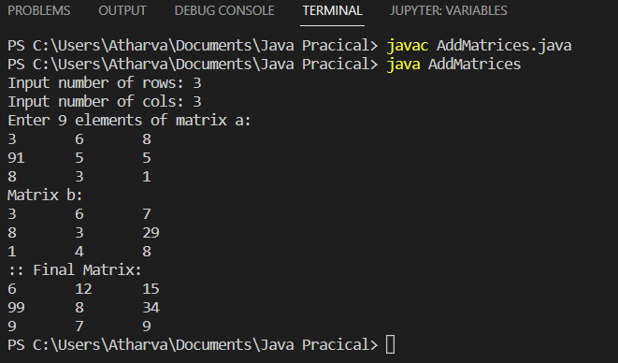

**A10-**  Write a Java program to find multiplication of two matrices. Accept matrix from user.

**Code:**

import java.util.Scanner;

public class MultiplyMatrices {

public static void main(String[] args)

{

int row, col;

Scanner sc = new Scanner(System.in);

System.out.print("Input number of rows: ");

row = sc.nextInt();

System.out.print("Input number of cols: ");

col = sc.nextInt();

int[][] a = new int[row][col]; //for matrix 1

int[][] b = new int[row][col]; //for matrix 2

int[][] c = new int[row][col]; //for matrix 3

System.out.println("Enter "+(row*col)+" elements of matrix a: ");

for (int i=0; i<row; i++)

{

for (int j=0; j<col; j++)

{

a[i][j] = sc.nextInt();

}

}

System.out.println("Enter "+(row*col)+" elements of matrix b: ");

for (int i=0; i<row; i++)

{

for (int j=0; j<col; j++)

{

b[i][j] = sc.nextInt();

}

}

System.out.println("Matrix a: ");

for (int i=0; i<row; i++)

{

for (int j=0; j<col; j++)

{

System.out.print(a[i][j] + "\t");

}

System.out.print("\n");

}

System.out.println("Matrix b: ");

for (int i=0; i<row; i++)

{

for (int j=0; j<col; j++)

{

System.out.print(b[i][j] + "\t");

}

System.out.print("\n");

}

for (int i=0; i<row; i++)

{

for (int j=0; j<col; j++)

{

for (int k=0; k<row; k++)

{

c[i][j] = c[i][j]+ a[i][k]*b[k][j];

}

}

}

System.out.println(":: Final Matrix: ");

sc.close();

for (int i=0; i<row; i++)

{

for (int j=0; j<col; j++)

{

System.out.print(c[i][j] + "\t");

}

System.out.print("\n");

}

}

}

**Output:** 